1. write a shell script to get value the pattern and file name from the user and check the pattern exists or not. If the pattern exists print the relavent

message , if pattern not found print relevent message.

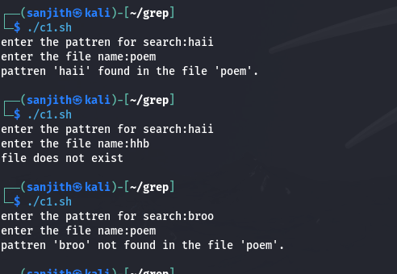

2. Modify the above script to pass the arguments from command line arguments.

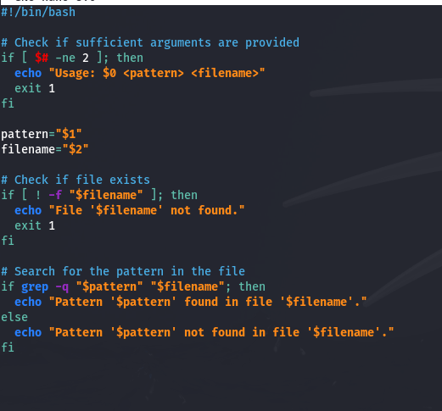

3. Modify the above script to pass the values inside the script.

